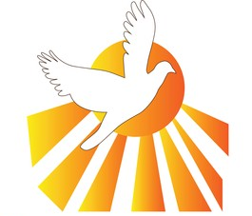
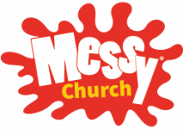

Your family and you are invited to join us at
Messy Church
on Sunday 5th May
at St Mary’s Church, Baldock
Starting at 11.30am until 1pm in the church hall.
Fun for all the family with crafts, short worship, and a hot meal.
The theme is ‘Pentecost’
No charge - Donations welcome.
Children must be accompanied by an adult.
Book your place by emailing messychurchbaldock@gmail.com All welcome!

