Lent books/ on line ideas for every day in Lent
Could you set aside some time every day during Lent to reflect? – these books might give you some ideas for your journey.
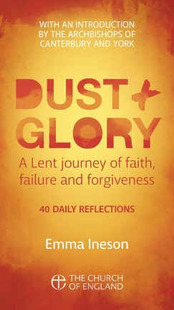
“Dust and Glory” is the Church of England's Lent campaign for 2023.
You can get daily email verses and reflections , or ask your Smart speaker to find them! Look at:
https://www.churchofengland.org/our-faith/what-we-believe/lent-holy-week-and-easter/dust-and-glory-lent-reflections
Offering 40 daily reflections for Lent on faith, failure and forgiveness, it invites you to find God in the mess of everyday life.

Booklets for adults and for children £1.99

Failure: What Jesus Said About Sin, Mistakes and Messing Stuff Up

The Archbishop of Canterbury's Lent Book 2023
Emma Ineson
A superb book on failure . . . humorous, realistic and absolutely not judgemental.' JUSTIN WELBY
In 2019, Emma Ineson wrote about ambition and what it means for Christians to be successful. And then there was a global pandemic . . .

£8.99

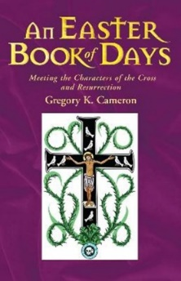
An Easter Book of Days
Meeting the characters of the cross and resurrection
Gregory Cameron
This book explores 25 characters from the stories of Lent, Holy Week and Easter from the perspectives of scripture, history and legend and asks how they can enrich our practice of faith today

£8.99

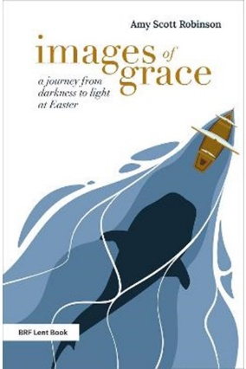
Images of Grace
A journey from darkness to light at Easter
Amy Scott Robinson
'At the heart of the Christian message is a collection of abstract nouns: love; sin; forgiveness; grace. But the problem with abstract nouns is that when we use them, we assume that the person we are talking to understands them, and not only that, we assume that they have the same understanding of the word that we do....’
£8.99

Now that our local Christian bookshop in Letchworth has sadly closed, please consider supporting Church House Publishing instead of Amazon to buy your faith based books

https://chbookshop.hymnsam.co.uk/features/lent-books-2023
Katrina Nice 12.2.23

