St. Mary the Virgin, Baldock.
St. Margaret of Antioch, Bygrave.
“BUILDING WITH CHRIST”
Thomas the Apostle
Worship on Sunday 3rd July 2022

8am Communion (traditional words)
A simple peaceful start to the day. The service will take place at the High Altar. We will be beginning to share the common chalice from today. Reverend Robert Evens will be leading and preaching today.
9.30am Parish Communion
Today is St Thomas's day - the disciple who needed to see Jesus with his own eyes to believe he had been raised from the dead. We are delighted to welcome Reverend Robert Evens who will be leading and preaching at this service. A reminder that you will (if you wish) be able to share the Peace by shaking hands.
If you do not wish to be visible on the streaming service please sit in the north aisle of the church nearest the organ. The camera does not capture anyone receiving communion.

Share in Parish Communion in your own home
Take part online either at 9.30am on Sunday or any time during the following week, click on this link: https://youtu.be/rFLo_ElNfS0

Next Sunday’s worship 10th July 2022
8.00am Communion
9.30am Parish Communion

Prayers and readings for this Sunday

Hymns:
687 - Through the night of doubt and sorrow
204 - Give us the wings of faith
514 - O Lord, we long to see your face
221 - God is working his purpose out

The Collect
Almighty and eternal God,
who, for the firmer foundation of our faith,
allowed your holy apostle Thomas
to doubt the resurrection of your Son
till word and sight convinced him:
grant to us, who have not seen, that we also may believe
and so confess Christ as our Lord and our God;
who is alive and reigns with you,
in the unity of the Holy Spirit,
one God, now and for ever.
Amen

The Old Testament Reading Habakkuk 2:1-4
2 I will stand at my watch-post, and station myself on the rampart; I will keep watch to see what he will say to me, and what he will answer concerning my complaint. ² Then the Lord answered me and said: Write the vision; make it plain on tablets, so that a runner may read it.
³ For there is still a vision for the appointed time; it speaks of the end, and does not lie. If it seems to tarry, wait for it; it will surely come, it will not delay. ⁴ Look at the proud! Their spirit is not right in them, but the righteous live by their faith.

The Choir will sing between the readings:

Word of God, burn within us, be a lamp unto our feet.
Test our hearts and our spirits, true disciples let us be.

The New Testament Reading Ephesians 2:19-end
¹⁹ So then you are no longer strangers and aliens, but you are citizens with the saints and also members of the household of God, ²⁰ built upon the foundation of the apostles and prophets, with Christ Jesus himself as the cornerstone. ²¹ In him the whole structure is joined together and grows into a holy temple in the Lord; ²² in whom you also are built together spiritually into a dwelling-place for God.
The Gospel John 20: 24-29
²⁴ Thomas (who was called the Twin), one of the twelve, was not with the disciples when Jesus came. ²⁵ So the other disciples told him, ‘We have seen the Lord.’ But he said to them, ‘Unless I see the mark of the nails in his hands, and put my finger in the mark of the nails and my hand in his side, I will not believe.’ ²⁶ A week later his disciples were again in the house, and Thomas was with them. Although the doors were shut, Jesus came and stood among them and said, ‘Peace be with you.’ ²⁷ Then he said to Thomas, ‘Put your finger here and see my hands. Reach out your hand and put it in my side. Do not doubt but believe.’ ²⁸ Thomas answered him, ‘My Lord and my God!’ ²⁹ Jesus said to him, ‘Have you believed because you have seen me? Blessed are those who have not seen and yet have come to believe.’

This week, please remember in your prayers these areas of our parish:

Hurst Close, Iredale View, Jeve Close, Rivett Close

Those in need of healing:
Paula Conder, Penny and Douglas Mitchell, Peter Harris, Oliver Britton, Martin Reed, Martyn Gray, Tracy Copping, Karen Kynman, Shaun Trussell, Andy Ball,
Jeanette Jackson, Stuart Hodges, Helen Walden, Nicky Bull, Daniel Muir, Laurie Browne.

Those who have died recently:

Everleigh Stroud, Lorna Harris, Peter Goodchild, Barbara Allcroft, Eden Moules,

Susan Kirby

Those whose anniversary of death is remembered this week

Gaynor Morgan, David Sheldrick, Kitty Lucker, Norman Guest, Brian Archer,

Peter Smith, baby Lily-Faye Beedell

Choir Anthem: 'I believe' by Philip Moore (b.1943)
I believe in the Sun, even when it's not shining.
I believe in Love, even when I feel it not.
I believe in God, even when he is silent.
I believe in the Sun, in Love, in God. I believe.

Post Communion
Lord God, the source of truth and love,
keep us faithful to the apostles’ teaching and fellowship,
united in prayer and the breaking of bread,
and one in joy and simplicity of heart,
in Jesus Christ our Lord
Amen
Thank you from Andrew and Helen:
We were extremely touched by the wonderful send-off you gave us on Sunday. Once we've come back down to earth a bit we will write more in next week's news sheet. But thank you so much for your love and openhearted support and friendship over the last extremely memorable 18 years. We'll probably be moving mid-July and will put contact details in next week when we hope it will be more finalised. Stay in touch and keep the Faith!

Eco Tip Trinity 3: Why not invest in silicone muffin cases or baking sheets, which saves buying paper cases or baking paper and can be used again and again, making baking more sustainable.

Bishop Michael’s farewell:
There is a farewell service for Bishop Michael on the 16th July at 5pm at the Cathedral in St Albans. The service is open to anyone in the Diocese who wishes to attend. All are welcome and there is no need for them to book or confirm attendance.

The next phase of restoration has started!
The scaffolding is up around the East end of the church, a temporary roof structure over the chancel and more scaffolding round the side of the South aisle porch to allow essential masonry repair to the turret adjacent to the porch. We hope to have a fully watertight church by the time the scaffolding is removed which is expected to be the end of October. We are fortunate in that there is likely to be little disruption to worship and other activities going on in the church or the churchyard. The work is expected to cost about £230,000 plus VAT so thank you to everyone who has been so generous to enable it to happen.

Sunday 4 September 12-2pm Family's Hands-On Eco Event
with David Chandler from A Rocha, the environmental Christian Charity who run the Eco Church scheme of which we are part (and going for our silver award). Come along for food and Eco fun as we all discover how important it is to care for all of God's creation as we seek to combat Climate Change.

New carpet for chancel and choir:
In the last phase of restoration we planned to lay a bespoke carpet in the chancel and choir to cover up the ugly bits of concrete and with some of the emblems from the Victorian tiling in the sanctuary. You may remember we voted on a bible text to be woven into the kneeling area in front of the altar rail for communion. You voted for: My peace I give to you. Sadly we could not install it 6 years ago because of leaky roofs directly above. However now the final section of roof is being repaired we can. The only problem is the cost. We do not have a figure yet but it is likely to be at least £8,000. Andrew and Helen are delighted to contribute to this before they go and at present we have donations of around £4,000. If you would like to help fund what will be a work of art in its own right please let David Morgan know. A sample of the carpet with the Victorian design is in a corner of the sanctuary.

Lectionary: if you would like a lectionary (from Advent Sunday 2022 onwards) please let Alex know.

Hidden Humour

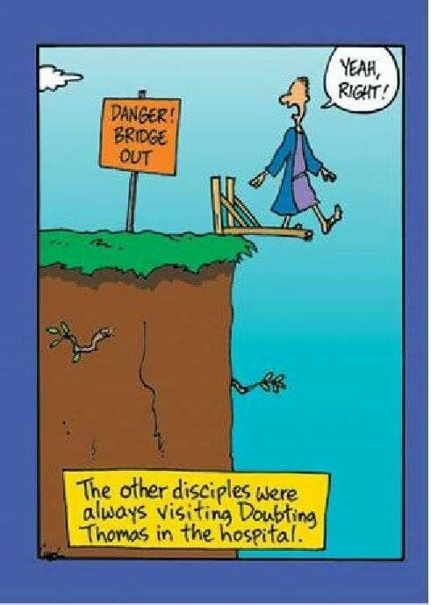

WEEK-AT-A-GLANCE

SUNDAY 3rd Thomas the Apostle
8.00am Holy Communion
9.30am Parish Communion
Mon 4th 2.00pm Funeral of Lorna Harris RIP
5.00pm Evening Prayer on Zoom
Tues 5th 2.00pm Silent Prayer on Zoom (contact Katrina)
Wed 6th 9.30am Holy Communion in church
10.30am Tiny Tots
4.15pm Junior Choir
4.45pm Evening Prayer on Zoom
7.30pm Bell ringing
Thurs 7th 5.00pm Evening Prayer on Zoom
6.45pm Senior Choir in church
SUNDAY 10th 4th Sunday after Trinity
8.00am Holy Communion
9.30am Parish Communion

Lay Minister: Katrina Nice: kmnice2013@gmail.com
Churchwarden: David Morgan: churchwarden@churchwarden.plus.com
07974 913041
Church email: baldockbenefice@gmail.com
Hall Hire: baldockchurchhall@gmail.com
Messy Church: messychurchbaldock@gmail.com
Website: www.stmarysbaldock.org.uk

Next week’s readings: Deuteronomy 30:9-14, Psalm 25:1-10, Colossians 1:1-14, Luke 10:25-37

CCLI number: 752089

Jesus said to him, ‘Have you believed because you have seen me? Blessed are those who have not seen and yet have come to believe.’

