Family Services
at St Mary’s Church
“BUILDING WITH CHRIST”
Sunday 19th December at 9.30am
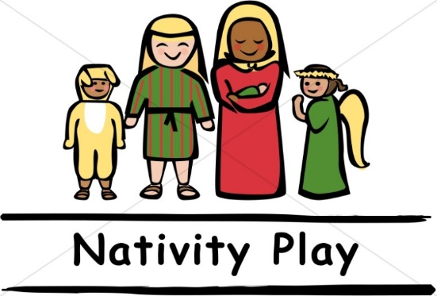
This Sunday we have our Nativity Play and Communion for All Ages service. Children are invited to come dressed as angels or shepherds. This is an all-age service which should put us all in the mood for the Christmas season.
Everyone welcome.
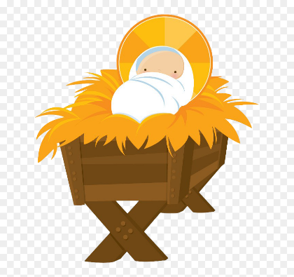
Christmas Eve at 3pm
Our Crib services is always a very special service and everyone is welcome. Please note, social distancing will not be possible at this service.

Sunday 2nd January at 10am
At 10.00am (note timing) we have a joint Messy Communion Service. Here we will be celebrating the arrival of the three Kings at the stable. There will lots to do for all ages, but especially toddlers and children. The theme will be thinking about what present we could give Jesus and what present he wants to give to us. It certainly won't be a quiet service!! Following the service we will be serving bacon butties (vegetarian option available). We would love for you to join us at this first service of the new year.

