 St. Mary the Virgin, Baldock.**   
**St. Margaret of Antioch, Bygrave.**

*“BUILDING WITH CHRIST”*

10th Sunday after Trinity

Worship on Sunday 8th August 2021

**Please wear a mask when you are moving around the church until you are sitting down. Please also wear it when you are singing.**

**8am****Communion (traditional words) in church**

*The return of the early morning communion service! The service will take place in the nave this week.*

[](http://www.google.co.uk/url?sa=i&rct=j&q=&esrc=s&source=images&cd=&cad=rja&uact=8&ved=2ahUKEwi8-duxvZLgAhXB1eAKHQOQAtwQjRx6BAgBEAU&url=http://kilternan.dublin.anglican.org/what-we-do.php&psig=AOvVaw2ExxGWwl1noL66jMiZfmsN&ust=1548833664679379)**9.30am****Communion for All Ages in church**Join us for family friendly worship. ~It was lovely last week to have   
the sound of children around the church again. We are planning this   
week similarly all age! The theme is ‘Living in the Kingdom of God, today’.   
*We are able to sing!! Distancing in the church is removed but we have designated the south aisle for those who still need to be cautious.*

Those sitting in the nave, in front of the streaming camera, may be visible on the streaming service video. If you would rather not be captured on screen in this way, please speak to a sidesperson who will offer you a seat not visible to the camera. The camera does not capture anyone receiving communion.

**Share in Parish Communion in your own home**

Take part in Parish Communion online either at 9.30am on Sunday or any time during the following week, click on this link: <https://youtu.be/iQOkSkh-X0k>

**6pm****Evening Prayer at Bygrave**

**Next Sunday’s worship (15th August):**

8am Communion (traditional words)

9.30am Parish Communion

6pm Evening Prayer at Bygrave

*Morning and Evening prayer are said nearly every day in church.   
See Week at a Glance for details and times.*

*Evening Prayer is Zoomed on Monday, Thursday and Saturday (use the link below).*

<https://us02web.zoom.us/j/81188370718?pwd=MVVDelNMbEppRldBYnFpN0NwT1hhQT09>

Meeting ID: 811 8837 0718 Passcode: 188423

*You are warmly invited to join the group of people who find this a valuable anchor for the day.*

*We have worked really hard to make worship in church as inclusive as possible and as vibrant as possible whilst keeping it as safe as possible. Here are some of the precautions we are taking:*

1. We are asking people to wear their masks until they reach their pews and when they are singing or moving around.
2. We are asking you not to use the south aisle as a thoroughfare unless you are sitting there.
3. We are still keeping a record of who attends for test and trace purposes.
4. We are inviting you to offer your collection when you come in (including contactless giving) rather than bringing the plate round during the offertory hymn
5. We are not asking you to do distance from each other but to be responsible and respectful of those who still wish to do so. We will continue to share the peace with waves rather than handshakes for the time being.
6. We are re-instating the children’s corner and it will be ok for children (and adults) to move around the church when they wish (avoiding the south aisle)
7. We hope to have an increased number of all age style communion until Junior Church restarts.
8. We are continuing to receive communion by walking to the Eucharistic minister and receiving a wafer dipped in the chalice (or just a wafer). People will also be able to receive a blessing when walking to the front as well. There will still be a general blessing afterwards for those watching on the streaming service. Those in the South aisle (who are socially distanced) and those behind the streaming camera near the font are encouraged to go the Eucharistic minister at the back of church.
9. We are serving refreshments after the service but encourage you to take your coffee outside or to a less crowded area.

**Prayers and readings for this Sunday**

**Hymns:**

573 Praise to the Lord  
67 Be still for the presence of the Lord  
299 I am the bread of life  
12 Alleluia sing to Jesus

**Collect**

Lord of heaven and earth,  
as Jesus taught his disciples to be persistent in prayer,  
give us patience and courage never to lose hope,  
but always to bring our prayers before you;  
through Jesus Christ our Lord.

**Amen**

**Psalm 34**

*Refrain:*

*Taste and see the goodness of the Lord.*

*Taste and see the goodness of the Lord.*

*Blessed are they who hope in God.*

*Taste and see the Lord is good indeed.*

I bless the Lord in ev'ry place and time,

In praise of God I shall lift up my voice

my soul shall make its boast in God alone,

hear him, all humble people, and rejoice.

Now join with me and glorify the Lord.

Together let us praise God's mighty name.

I sought the Lord and he has answered me;

and set me free from all my fear and shame.

Look on the Lord and let him shine on you;

let not your face be hidden, turned away.

The poor cry out, and God will heed their call,

and rescue them from trouble ev'ry day.

**New Testament Reading Ephesians 4: 25 – 5: 2**

25Putting away falsehood, let all of us speak the truth to our neighbours, for we are members of one another. 26Be angry but do not sin; do not let the sun go down on your anger, 27and do not make room for the devil. 28Thieves must give up stealing; rather let them labour and work honestly with their own hands, so as to have something to share with the needy. 29Let no evil talk come out of your mouths, but only what is useful for building up, as there is need, so that your words may give grace to those who hear. 30And do not grieve the Holy Spirit of God, with which you were marked with a seal for the day of redemption. 31Put away from you all bitterness and wrath and anger and wrangling and slander, together with all malice, 32and be kind to one another, tender-hearted, forgiving one another, as God in Christ has forgiven you.

1Therefore be imitators of God, as beloved children, 2and live in love, as Christ loved us and gave himself up for us, a fragrant offering and sacrifice to God.

**Gospel John 6: 35, 41 - 51**

35 Jesus said to the crowd, ‘I am the bread of life. Whoever comes to me will never be hungry, and whoever believes in me will never be thirsty.’

41Then the Jews began to complain about him because he said, ‘I am the bread that came down from heaven.’ 42They were saying, ‘Is not this Jesus, the son of Joseph, whose father and mother we know? How can he now say, “I have come down from heaven”?’ 43Jesus answered them, ‘Do not complain among yourselves. 44No one can come to me unless drawn by the Father who sent me; and I will raise that person up on the last day. 45It is written in the prophets, “And they shall all be taught by God.” Everyone who has heard and learned from the Father comes to me. 46Not that anyone has seen the Father except the one who is from God; he has seen the Father. 47Very truly, I tell you, whoever believes has eternal life. 48I am the bread of life. 49Your ancestors ate the manna in the wilderness, and they died. 50This is the bread that comes down from heaven, so that one may eat of it and not die. 51I am the living bread that came down from heaven. Whoever eats of this bread will live for ever; and the bread that I will give for the life of the world is my flesh.’

This week, please remember in your prayers these areas of our parish:

Hillside Park, Limekiln Lane, The Copse, Penfold Close,   
Providence Court, Providence Way.

Those in need of healing:

Paula Conder, Penny and Douglas Mitchell, Peter Harris, Oliver Britton, Martin Reed, Dick Haynes, David Dane, Alan Russell, Martyn Gray, Margaret Arthur, Tracy Copping, Karen Kynman, Jean Schurch, Jeanette Jackson, Sheila Wadsworth, Shaun Trussell.

Those who have died recently  
Ron Crumpholt

Those whose anniversary of death is remembered this week

Vera Dear, Anne Taylor, David Manning, Molly Cooper.

**Post Communion**

God of our pilgrimage,  
who hast willed that the gate of mercy  
should stand open for those who trust in thee:  
look upon us with thy favour  
that we, following in the path of thy will,  
may never wander from the way of life;  
through Jesus Christ our Lord.

**Amen**

**Church Appeal update**

**Very many thanks to everyone who has helped deliver leaflets. Please can you help with the last few? The results are really encouraging and I think we have already passed the £15,000 point.**

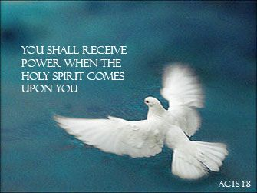We are beginning to make more definite plans for the mission next year. More details soon. Please keep praying for this exciting and important initiative. We are planning the mission around the theme of God’s creation and climate change.

**Eco Tip Trinity 10:** Addressing the Climate Crisis is all about living a less materialistic life and reducing global warming by stopping using fossil fuels and by caring for all global creation. Why not speak out and urge our leaders to take action now by petitioning for change or joining walks and protests leading up to the UN  climate talks, COP26, in November where the world needs to hear of real and immediate commitment to save our planet from burning up!

**Weds 11 August, 1pm: Come and join a Picnic & Prayers at St Albans Abbey**to welcome the Youth Christian Climate Network Relay who are leading a pilgrimage from Cornwall (G7 summit) to Glasgow (COP26) . Why not join them in the afternoon walking to Hemel Hempstead (all age!) to highlight Christians' concern for the Climate Crisis and the need for far-reaching immediate action to save the whole of God's creation from the dangerous rise in global temperatures. More info from Katrina 07708 064294 and [www.yccn.uk](http://www.yccn.uk/)

We hope to start the next **Faith Confirmed** Group within the next few months. If you would like to find out more about the Christian Faith or if you would like to be confirmed, this group is for you. Subtitled *‘101 questions about faith you always wanted to know but never dared ask’* it allows discussion and questions about everything from prayer to what you think about the Holy Spirit. About what happens at communion to Christian moral standards. If someone asked you what a Christian was, would you know how to reply? Faith confirmed helps you think about your answer to this question and to decide if it applies to you. Speak to Andrew if you are interested.

**Admission to Communion:** We plan to run a small group for children in Year 5 or above to admit them to communion so they are able to take a full part in the communion services in church. If you or your child would like to be part of this group and you have not already responded, please let Andrew know. We can then arrange the sessions at a convenient time for you.

The next communion at Magdalene Court is on Monday 16th August at 10.30am

**Hidden Humour**

**If you make money selling Indian bread...**

You run a Naan Profit Organization.

[](https://www.google.co.uk/url?sa=i&rct=j&q=&esrc=s&source=images&cd=&ved=2ahUKEwjdlZ28l9fkAhXlzoUKHVwzDhgQjRx6BAgBEAQ&url=https://www.metrolife.org/blog/post/i-love-my-crazy-home-group--and-i-should-be-committed&psig=AOvVaw0ZXQ3FP1dyYJxdrtApc98O&ust=1568786534826351)

Our Home Groups are operating on Monday evening at 8pm, Tuesday evening at 7.30pm and Thursday morning at 10.30am. See Week at a Glance for dates.

**The return of Tiny Tots!!**

Tiny Tots will restart on Wednesday 18th August at 10.30am. Do join us for Christian growth for pre-schoolers and companionship for adults!!

**Junior Choir**

Junior Choir is planned to start in September Probable time and day: Wednesday 4pm – 4.45pm. Please speak to Madeleine Middleton for more details.

Next week’s readings: Isaiah 61: 10 – end; Psalm 45: 10 – end; Galatians 4: 4 – 7; Luke 1: 46 - 55

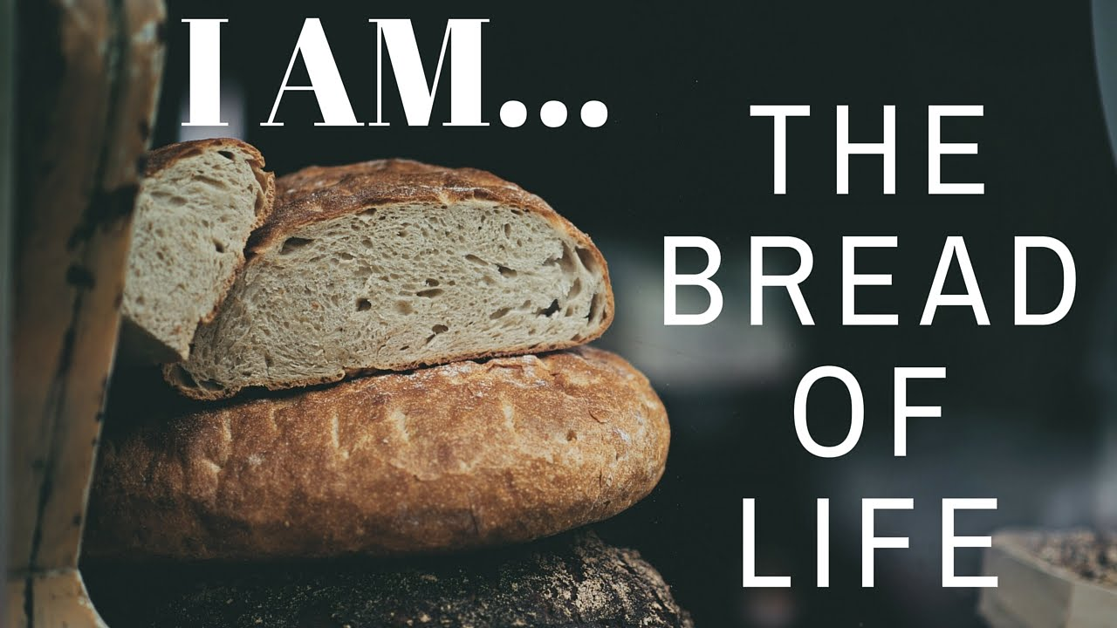

**WEEK-AT-A-GLANCE**

SUNDAY 8th *10th Sunday after Trinity*

AUGUST 7.20am Morning Prayer in church

8.00am Holy Communion (Preacher: Andrew)

9.30am Communion for All Ages (Preacher: Andrew)

6.00pm Evening Prayer at Bygrave

Mon 9th *Mary Sumner founder of the Mothers’ Union 1921*  
 8.40am Morning Prayer in church

5.00pm Evening Prayer on Zoom

8.00pm Monday Home Group on Zoom (contact Emma)

Tues 10th *Laurence, Deacon at Rome, Martyr AD258*8.40am Morning Prayer in church

2.00pm Silent Prayer on Zoom (contact Katrina)

Wed 11th *Claire of Assisi, Founder of the Poor Clares AD1253*  
9.30am Holy Communion (Robert Evens)

5.00pm Evening Prayer in church

Thurs 12th 8.40am Morning Prayer in church  
5.00pm Evening Prayer on Zoom   
6.45pm Choir practice

Fri 13th *Jeremy Taylor, Bp of Down and Connor, Teacher of the Faith, AD1667* 8.40am Morning Prayer in church  
 5.00pm Evening Prayer on Zoom

Sat 14th 9.30am Morning Prayer in church

5.00pm Evening Prayer and in church

SUNDAY 15th *The Blessed Virgin Mary*

7.20am Morning Prayer in church

8.00am Holy Communion (Preacher: Andrew)

9.30am Parish Communion (Preacher: Andrew)

6.00pm Evening Prayer at Bygrave

Be imitators of God, as beloved children, and live in love, as Christ loved us and gave himself up for us, a fragrant offering and sacrifice to God.

**CCLI number: 752089**

**Rector:** Rev’d Canon Andrew Holford: 01462 896273 [2008luddite@gmail.com](mailto:2008luddite@gmail.com)

**Lay Minister:** Katrina Nice: kmnice2013@gmail.com / 07708 064294

**Alex Milne – Hall Hire:** [baldockbenefice@gmail.com](mailto:baldockbenefice@gmail.com) **/ 01462 896149**

**Church email:**  [baldockbenefice@gmail.com](mailto:baldockbenefice@gmail.com);

**Website:** [www.stmarysbaldock.org.uk](http://www.stmarysbaldock.org.uk)