 St. Mary the Virgin, Baldock.**   
**St. Margaret of Antioch, Bygrave.**

*“BUILDING WITH CHRIST”*

Second Sunday of Easter

Worship on Sunday 11th April 2021

**9am****Parish Communion in church**

Share in the sacrament of communion. Wear a mask unless you are exempt. We areespecially delighted the choir are able to sing with us again. Wear a mask unless you are exempt. Toilets are available in the church hall. Please ask a sidesperson if you need access.

Those sitting in the nave, in front of the streaming camera, may be visible on the streaming service video. If you would rather not be captured on screen in this way, please speak to a sidesperson who will offer you a seat not visible to the camera. The camera does not capture anyone receiving communion.

**Share in Parish Communion in your own home**

Take part in Parish Communion online either at 9am on Sunday or any time during the following week, click on this link:  <https://youtu.be/Ud1lg5PsdmU>

**10.15am****Zoom Morning Worship**

<https://us02web.zoom.us/j/85865137528?pwd=ZjVrV25sMzJKanNTN3pNZjdqMXVYdz09>

**Meeting ID: 858 6513 7528 Passcode: 827152**

**11.15am****Family Worship at Bygrave**

Wear a mask unless you are exempt. Worship for all ages. All age bible readings and prayers. Activities and videos.

**6pm Zoom Evening Prayer**

<https://us02web.zoom.us/j/81188370718?pwd=MVVDelNMbEppRldBYnFpN0NwT1hhQT09>

**Meeting ID: 811 8837 0718 Passcode: 188423**

Evening Prayer is Zoomed most days. You are warmly invited to join us!

(check Week at a Glance for times on specific days)

<https://us02web.zoom.us/j/81188370718?pwd=MVVDelNMbEppRldBYnFpN0NwT1hhQT09>

Meeting ID: 811 8837 0718 Passcode: 188423

*Morning Prayer, usually at 8.40am, and some Evening Prayer will be said in church.   
You are also warmly invited to join in. See Week at a Glance for days and times*

*The Church is open Monday – Saturday at roughly 9am - 3.30pm for private prayer.*

[](https://www.google.co.uk/url?sa=i&rct=j&q=&esrc=s&source=images&cd=&ved=2ahUKEwjdlZ28l9fkAhXlzoUKHVwzDhgQjRx6BAgBEAQ&url=https://www.metrolife.org/blog/post/i-love-my-crazy-home-group--and-i-should-be-committed&psig=AOvVaw0ZXQ3FP1dyYJxdrtApc98O&ust=1568786534826351)Our Home Groups are operating on Monday evening at 8pm, Tuesday evening at 7.30pm and Thursday morning at 10.30am. See Week at a Glance for dates. And our children and young people meet most Sunday evening for a Zoom session. Get in touch for more details.

*If you are aware of anyone who is unable to get food or medication etc, or people who are facing extra stress and anxiety or other problems and you cannot care for them yourselves, please get in touch. .... and please continue praying for each other and for the wounded world in which we live.  If you are struggling yourself, please do not keep silent.*

**Prayers and readings for this Sunday**

**Hymn 433 Love’s redeeming work is done**

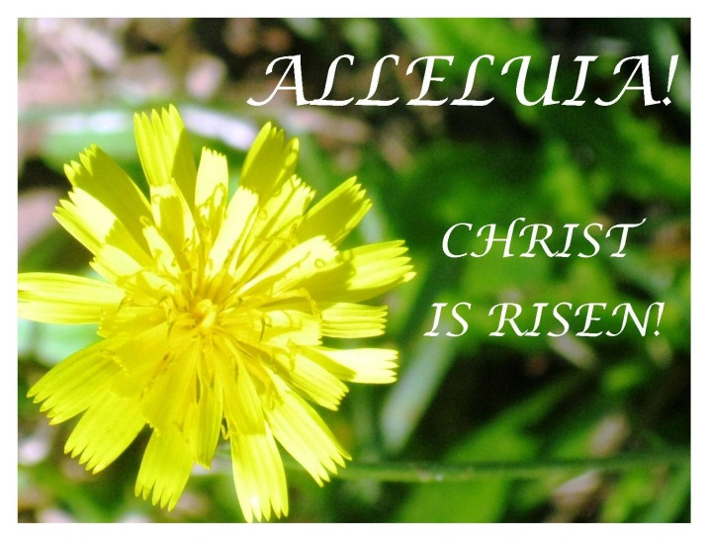Love’s redeeming work is done;  
fought the fight, the battle won:  
lo, our sun’s eclipse is o’er!  
Lo, he sets in blood no more!  
  
Vain the stone, the watch, the seal!  
Christ has burst the gates of hell;  
death in vain forbids his rise;  
Christ has opened Paradise.   
  
Lives again our glorious King;  
where, O death, is now thy sting?  
Dying once, he all doth save;  
where thy victory, O grave?  
  
Soar we now where Christ has led,  
following our exalted head;  
made like him, like him we rise;  
ours the cross, the grave, the skies.  
  
Hail the Lord of earth and heaven!  
Praise to thee by both be given:  
thee we greet triumphant now;  
hail, the resurrection thou!

**Collect**

Risen Christ,  
for whom no door is locked, no entrance barred:  
open the doors of our hearts,  
that we may seek the good of others  
and walk the joyful road of sacrifice and peace,  
to the praise of God the Father. Amen.

**New Testament reading Acts 4: 32 – 35**

32The whole group of those who believed were of one heart and soul, and no one claimed private ownership of any possessions, but everything they owned was held in common. 33With great power the apostles gave their testimony to the resurrection of the Lord Jesus, and great grace was upon them all. 34There was not a needy person among them, for as many as owned lands or houses sold them and brought the proceeds of what was sold. 35They laid it at the apostles’ feet, and it was distributed to each as any had need.

USED IN 9.30am WORSHIP ONLY

**Psalm 133**

*Hallelujah! Hallelujah! Hallelujah!*

How good and pleasant it is for a community to live in harmony.

**It is like fine oil upon the beard,   
down Aaron’s beard to the hem of his robe.**

It is like the dew of Mount Hermon, which falls on the hills of Zion.

**That is where the Holy One has ordained the blessing,  
life for evermore.**

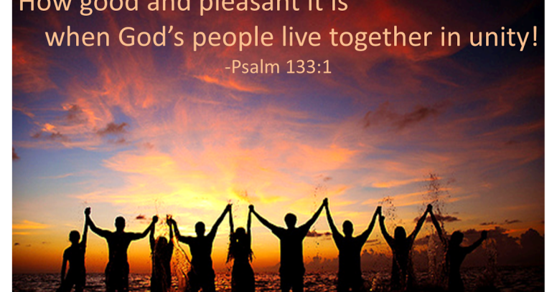*Hallelujah! Hallelujah! Hallelujah!*

NOT USED IN OUR WORSHIP

**New Testament reading 1 John 1: 1 – 2: 2**

1We declare to you what was from the beginning, what we have heard, what we have seen with our eyes, what we have looked at and touched with our hands, concerning the word of life – 2this life was revealed, and we have seen it and testify to it, and declare to you the eternal life that was with the Father and was revealed to us – 3we declare to you what we have seen and heard so that you also may have fellowship with us; and truly our fellowship is with the Father and with his Son Jesus Christ. 4We are writing these things so that our joy may be complete.

5This is the message we have heard from him and proclaim to you, that God is light and in him there is no darkness at all. 6If we say that we have fellowship with him while we are walking in darkness, we lie and do not do what is true; 7but if we walk in the light as he himself is in the light, we have fellowship with one another, and the blood of Jesus his Son cleanses us from all sin. 8If we say that we have no sin, we deceive ourselves, and the truth is not in us. 9If we confess our sins, he who is faithful and just will forgive us our sins and cleanse us from all unrighteousness. 10If we say that we have not sinned, we make him a liar, and his word is not in us.

1My little children, I am writing these things to you so that you may not sin. But if anyone does sin, we have an advocate with the Father, Jesus Christ the righteous; 2and he is the atoning sacrifice for our sins, and not for ours only but also for the sins of the whole world.

**Gospel John 20: 19 – end**

19When it was evening on the first day of the week, and the doors of the house where the disciples had met were locked for fear of the Jews, Jesus came and stood among them and said, ‘Peace be with you.’ 20After he said this, he showed them his hands and his side. Then the disciples rejoiced when they saw the Lord. 21Jesus said to them again, ‘Peace be with you. As the Father has sent me, so I send you.’ 22When he had said this, he breathed on them and said to them, ‘Receive the Holy Spirit. 23If you forgive the sins of any, they are forgiven them; if you retain the sins of any, they are retained.’

24But Thomas (who was called the Twin), one of the twelve, was not with them when Jesus came. 25So the other disciples told him, ‘We have seen the Lord.’ But he said to them, ‘Unless I see the mark of the nails in his hands, and put my finger in the mark of the nails and my hand in his side, I will not believe.’

26A week later his disciples were again in the house, and Thomas was with them. Although the doors were shut, Jesus came and stood among them and said, ‘Peace be with you.’ 27Then he said to Thomas, ‘Put your finger here and see my hands. Reach out your hand and put it in my side. Do not doubt but believe.’ 28Thomas answered him, ‘My Lord and my God!’ 29Jesus said to him, ‘Have you believed because you have seen me? Blessed are those who have not seen and yet have come to believe.’

30Now Jesus did many other signs in the presence of his disciples, which are not written in this book. 31But these are written so that you may come to believe that Jesus is the Messiah, the Son of God, and that through believing you may have life in his name.

This week, please remember in your prayers these areas of our parish:

Ashwell Road, Wedon Way, Church Lane

Those in need of healing:  
Paula Conder, Penny and Douglas Mitchell, Olive Elves, Peter Harris, Oliver Britton, Martin Reed, Martyn Gray, Ron Crumpholt, Dick Haynes, David Dane, Alan Russell, Jeanette Jackson, Margaret Arthur, Tracy Copping, Karen Kynman, Jean Schurch.

Those who have died recently

Sylvia Lawrance, Jo Meaker

Those whose anniversary of death is remembered this week

Gwen Hunter, Ivy Cesvette, Eva Stokes, David Davies, Paul Browne, Maud Castle, Rose Myers

**Post Communion**

Lord God our Father,  
through our Saviour Jesus Christ  
you have assured your children of eternal life  
and in baptism have made us one with him:  
deliver us from the death of sin  
and raise us to new life in your love,  
in the fellowship of the Holy Spirit,  
by the grace of our Lord Jesus Christ.. **Amen**

**Hymn 198 From the very depths of darkness**

From the very depths of darkness  
springs a bright and living light;  
out of falsehood and deceit  
a greater truth is brought so sight;  
in the halls of death, defiant,  
life is dancing with delight!  
The Lord is risen indeed!

*Christ is risen! Hallelujah! (x3)*

*The Lord is risen indeed!*

Jesus meets us at the dawning   
of the resurrection day;  
speaks our name with love, and gently  
says that here we may not stay:  
‘Do not cling to me, but go to all the fearful ones and say,  
“The Lord is risen indeed!”’

*Christ is risen! Hallelujah! (x3) …*

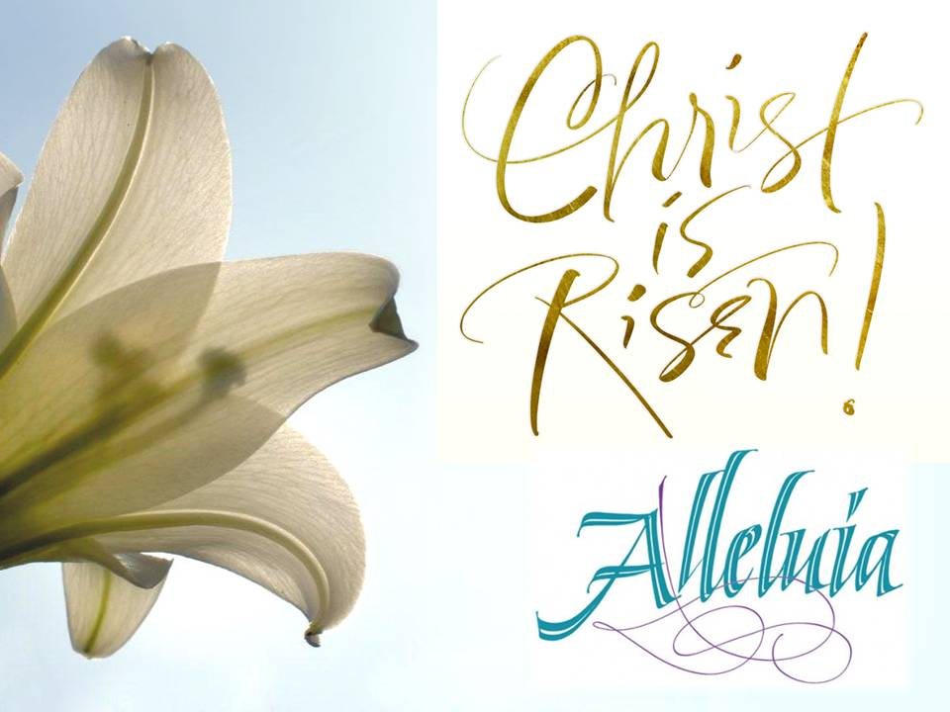So proclaim it in the high-rise,  
in the hostel let it ring;  
make it known in Cardboard City,  
let the homeless rise and sing:  
‘He is Lord of life abundant,  
and he changes everything;  
the Lord is risen indeed!’

*Christ is risen! Hallelujah! (x3)*

*The Lord is risen indeed!*

In the heartland of oppression,  
sound the cry of liberty;  
where the poor are crucified,  
behold the Lord of Calvary;  
from the fear of death and dying,  
Christ has set his people free;  
the Lord is risen indeed!

*Christ is risen! Hallelujah! (x3) …*

To the tyrant, tell the gospel  
of a love that can’t be known  
in a guarded palace-tomb,  
condemned to live and die alone:  
‘Take the risk of love and freedom;  
Christ has rolled away the stone!  
The Lord is risen indeed!’

*Christ is risen! Hallelujah! (x3) …*

When our spirits are entombed  
in mortal prejudice and pride;  
when the gates of hell itself  
are firmly bolted from inside;  
at the bidding of his Spirit,  
we may fling them open wide;  
The Lord is risen indeed!

*Christ is risen! Hallelujah! (x3) …*

We are sorry for the poor sound quality of the streaming service over the last few weeks. It seems mainly to be to do with the position of the camera; what is best for vision is not necessarily best for sound. We will be experimenting and seeking advice over the next few weeks about how to get the best of both worlds!

**Eco Tip for Second Sunday of Easter:** A topical tip unless people have already got rid of all their Easter egg wrappers! Collect the foil from your Easter egg munching plus other bits of clean foil (eg milk bottle tops) in a clean foil pie dish, crumple them together into a ball and put in the recycling (small pieces of foil on their own won't be recognised by recycling machines!)

Your **Eco Church Group** should have some great news on an award very soon! Let's all keep going in an Eco direction! Try to walk or cycle to church services / events if you are able - it might simply mean having to leave the house a few minutes earlier (note to self, Katrina) - it all helps the environment to leave your car at home!"

The **foodbank** would be very grateful to receive donations of tinned tuna, tomatoes, rice pudding, sponge pudding, long life fruit juice and squash. These can be delivered to the church hall any Tuesday or Friday morning between 10 am and 12 noon. Thank you.

**Hidden Humour**

"Remember son, a smart person always has doubts about something. Only a total idiot is 100% sure about everything."

"Dad, are you sure?"  
"Absolutely!"

Forthcoming meeting dates

Baldock APCM Sunday 18th April at 11.15am on Zoom

15 Houses Charity Trustees Tuesday 20th April at 8pm on Zoom

Osbourne Court worship Thursday 22nd April at 11am on Zoom

Bygrave APCM Tuesday 27th April at 7.30pm

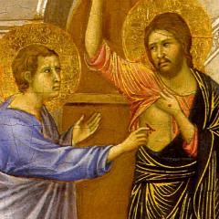The Baldock Annual Parochial church Meeting will be on Sunday 18th April at 11.15am on Zoom. It will use the same code as Morning Worship. Hope to see you there!

**WEEK-AT-A-GLANCE**

**SUNDAY 11th Second Sunday of Easter**

8.00am Morning Prayer in church

9.00am Parish Communion in church

10.15am Morning Worship on Zoom

11.15am Family Worship at Bygrave

6.00pm Evening Prayer on Zoom

Mon 12th 5.00pm Evening Prayer on Zoom

8.00pm Monday Home Group (contact Emma)

Tues 13th *St Mary’s schools restart today*  
2.00pm Silent Prayer contact Katrina  
5.00pm Evening Prayer on Zoom

Wed 14th 8.40am Morning Prayer in church

9.30am Holy Communion

5.00pm Evening Prayer on Zoom and in church

Thurs 15th 8.40am Morning Prayer in church  
 10.30am Thursday Home Group contact Katrina

5.00pm Evening Prayer on Zoom   
 6.45pm Choir practice

Fri 16th 8.40am Morning Prayer in church

5.00pm Evening Prayer on Zoom

Sat 17th 5.00pm Evening Prayer on Zoom

SUNDAY 18th *Third Sunday of Easter*

8.00am Morning Prayer in church

9.00am Parish Communion in church

10.15am Morning Worship on Zoom

11.15am St Mary’s APCM on Zoom

6.00pm Evening Prayer on Zoom

Jesus came and stood among them and said, ‘Peace be with you.’

Next week’s readings: Acts 3: 12 - 19, Psalm 4, 1 John 3: 1 - 7, Luke 24: 36b - 48

**CCLI number: 752089**

**Rector:** Rev’d Canon Andrew Holford: 01462 896273 [2008luddite@gmail.com](mailto:2008luddite@gmail.com) **Lay Minister:** Katrina Nice: kmnice2013@gmail.com / 07708 064294

**Alex Milne – Hall Hire:** [baldockbenefice@gmail.com](mailto:baldockbenefice@gmail.com) **/ 01462 896149**

**Church email:**  [baldockbenefice@gmail.com](mailto:baldockbenefice@gmail.com);

**Website:** [www.stmarysbaldock.org.uk](http://www.stmarysbaldock.org.uk)