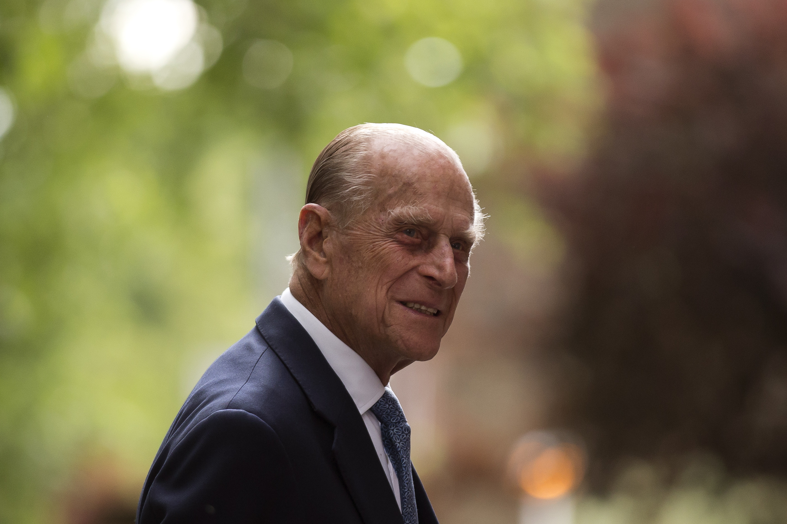
Friday 9 April 2021

It is with great sadness that I received the news this morning that His Royal Highness The Duke of Edinburgh has died. Please join me in prayer for His Royal Highness and for Her Majesty The Queen and other members of the Royal Family in their grief, and in thanksgiving for His Royal Highness’s
long and fruitful life of service.

His Royal Highness led life as a Naval Officer, as Consort to Her Majesty
The Queen and as a father, grandfather and great-grandfather.

In service of the monarchy, he accompanied and supported Her Majesty
The Queen both in this country and around the world, including many visits
to the Diocese of St Albans. We are grateful to have welcomed him here.

Throughout his life, His Royal Highness was deeply involved with a large number of charities and is particularly well known for The Duke of Edinburgh’s Award, which has influenced the lives of many young people. He was also an accomplished amateur artist, polo player, yachtsman and, later in life, he excelled at carriage driving.

He was a unique individual in our national life and a memorable character.

His Christian faith sustained him throughout his life, and we pray for him in the sure and certain hope of the resurrection to eternal life through our Lord Jesus Christ.

May he rest in peace.

+Alan St Albans

