Community Easter Garden
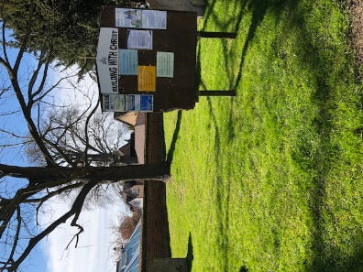
We have decided to create our Easter garden in the church grounds again this year as the community enjoyed it so much last year. However, in order to do this, Paul and I need your help!
We will probably constructed it again close to the notice board so that it can be seen from Hitchin street.
If you can help with any of the following we would be very grateful:
- We need pots, ideally planted with plants! These could easily be stolen, so please make sure they are not your prize winning exhibits!
- We need soil, turf or moss to use to cover the tomb on top of the black, weed preventing material.
- We need a round stone for the entrance to the tomb – the size of
the tomb will depend on the size of the stone or garden. A round stepping stone or a paving stone would probably work.
- We need other small stones of different textures and colours and all shapes and sizes to be used to fill in gaps and to possibly create a path as shown in one of the pictures below.
- We need plants which can be planted in the pots!
- We need three wooden crosses – it would be good if these were quite large as then they will stand out better from the road.
- Any design ideas,
- We need anything else that I haven’t thought of!
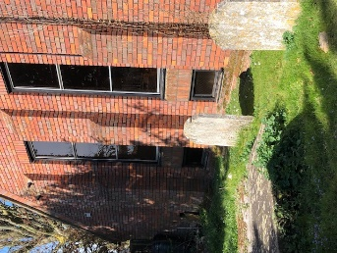
If you have plants, pots, soil or stones etc which could be used, these could be left during the week at the back of the bee garden underneath the hall windows. This area is quite shaded. Remember I will need to transport them over to the area so nothing too heavy please. If they are heavy, you may wish to put them by the notice board in readiness.
The garden will be constructed on Good Friday afternoon so that the tomb can be closed over Easter Saturday and then opened on Easter morning.
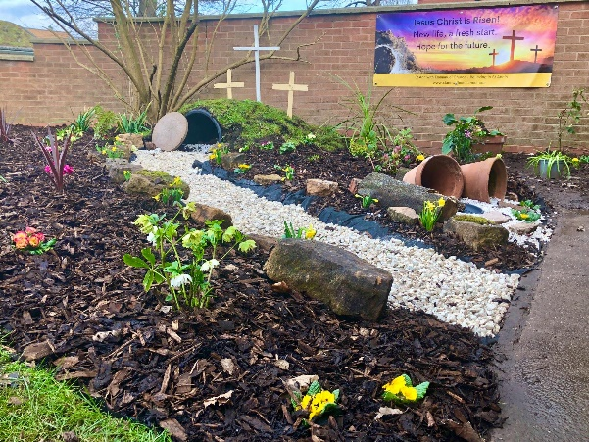
If you are able to help with providing any materials but can’t get them to the church, please get in touch either by email wilks1965@yahoo.com or phone 07836749283
Many thanks
Emma Wilkinson and Paul Dougal

